1. Determine the asymptotic running time of the following procedure (an exact number of primitive operations is not necessary):

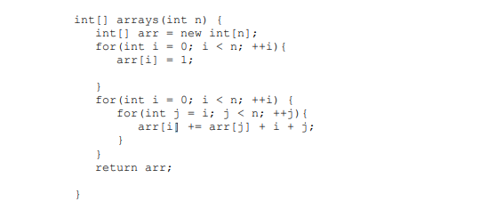

Int[] arr=new int[n] ------🡪 1

For loop ………………………> n+3

Again assignment ………..> 1

Nested For loop ………………> O(n2)

Total= O(n)+O(n2)=**O(n2)**

1. Consider the following problem: As input you are given two sorted arrays of integers. Your objective is to design an algorithm that would merge the two arrays together to form a new sorted array that contains all the integers contained in the two arrays. \

For example, on input

[1, 4, 5, 8, 17], [2, 4, 8, 11, 13, 21, 23, 25]

the algorithm would output the following array:

[1,2,4,4,5,8,8, 11, 13, 17, 21, 23, 25]